**Oxford Prospects Short Programmes Proposed Agenda**

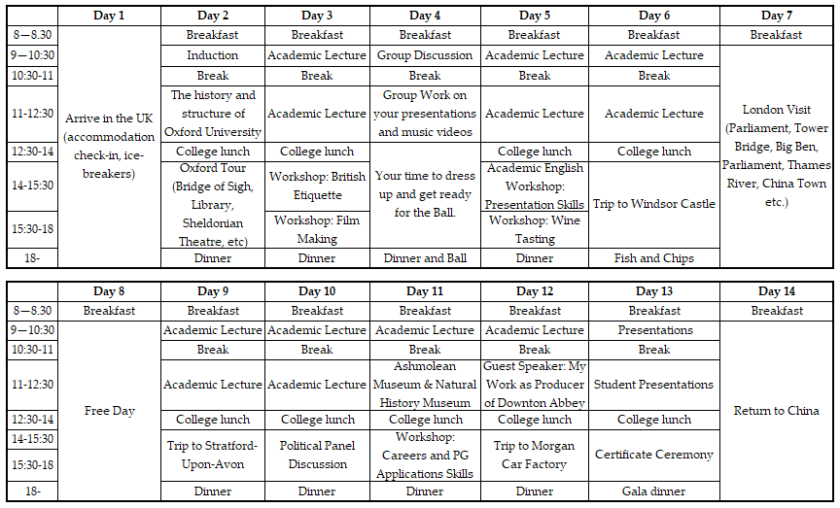

*Proposed timetable subject to minor changes.*